Rainbow Write your sight words.  them  play  mom | Write your sight words in shaving cream, salt or sand. | Write your sight words in CAPITAL letters and lowercase letters.  EX. DID did  SHE she | Put your sight words in ABC order.  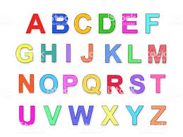
Pyramid Write your sight words.  Ex.  m  ma  mad  made | Using a computer, type your sight words and read them out loud while you are typing. If you are able to, print them out to help you study. | Divide your sight word into syllables.  Ex. Anyone: /any/  /one/ | Write your sight on index cards (two of each word) Flip them over to try and find a match. Say the word when you make a match.
Write a sentence using your sight words and underline the word in each sentence.  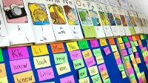 | Watch a youtube video on sight words. Just type in “sight word songs” and pick one or more of your choice. | Write your sight words with a white crayon. Then use a marker and color your paper. Read the words when you find them! | Pick 5 sight words that you are having difficulty with and write them as many times as you can in one minute. Have a grown up help you.
Make flashcards with your sight words. Practice them with a family member. | Write your words using blue for consonants and red for vowels.  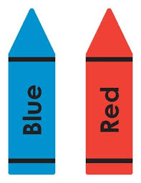 | Get some playdough and roll it out. Write the words in the playdough using a pencil or your finger. You can also use the playdough to make the words. | Use a magazine or a newspaper and highlight or circle sight your sight words.  to my see can so  ©Stephanie Lyons

